**Enrolling in a Class**

Students must enroll in a class before they can begin using Turnitin. In order to enroll in a class the student must have the class id and enrollment password which can only be distributed by the class instructor. Students can enroll in multiple classes from the same user profile.

**How to create a new user profile and enroll in a class**

1. Click the "Create Account" link to the left of the Sign in button on the Turnitin homepage  
   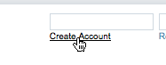
2. Click on the student link from the Create a New Turnitin Account screen  
   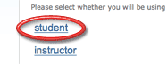
3. Enter your class id and enrollment password in the appropriate fields  
   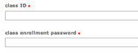
4. Enter your first name, your last name, and the e-mail address you would like associated with your Turnitin account (this will be your user name)  
   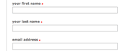
5. Enter (and re-enter) the password you would like to use as your Turnitin login password  
   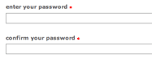
6. Select a secret question using the secret question pull down menu, enter an answer  
   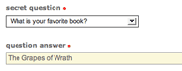
7. Review the Turnitin user agreement and click to agree and finalize user profile creation<  
   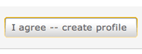

Students with pre-existing user profiles can use the enroll in a class tab to enroll in additional classes.

1. Click on the enroll in a class tab on your student homepage  
   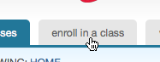
2. Enter the class id and enrollment password (see top of page)  
   
3. Click submit to enroll in the class  
   

**Additional Information**

* All passwords in Turnitin are case sensitive
* Turnitin user login passwords must be between 6-12 character in length and contain both letters and numbers
* You will need to remember your secret question and answer if you forget your login password in the future. Please select the question with this in mind and answer the question with the correct response.